Mixed Precision Block QR

**Week 1 (1/3/22 – 1/10/22)**

# Kickoff with Amazon

First meeting with Tong Qin of Amazon Lab 126.

**Goal:** Come up with a mixed-precision block QR decomposition and run it on NividiaGPU.

**Stretch Goal**: Integrate the CUDA QR into open-source package and test it on real-world structure from motion problems.

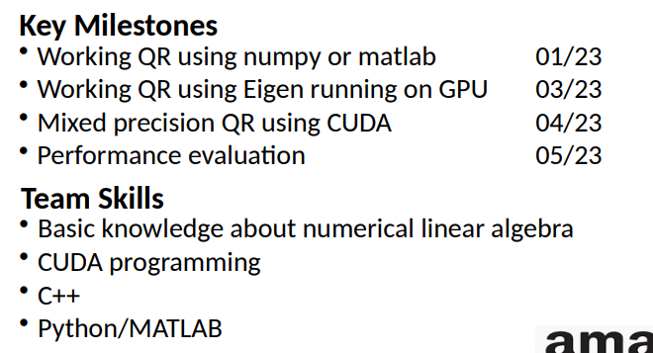

## Action Items

* Fix Job roles (must include descriptions of roles for UW)

|  |  |  |
| --- | --- | --- |
| Name | Administrative Role | Technical Role |
| Jaidon Lybbert | Point of Contact | CUDA C++ Developer |
| Fulin Li | Finances | Python Developer |
| Shashank Shivashankar |  | CUDA C++ Lead Developer |
| Alice |  | Python Lead Developer |
| Yiming Du | Documentation / Submitter | C++ / Python Developer |
| Mike Pao |  | Python Developer |

* ~~Team manager sets up GitHub repo~~
  + <https://github.com/jaidonlybbert/MixedPrecisionBlockQR>
* Read the mixed-precision QR paper with the following questions in mind – What is IEEE fp16? – What is QR and how it helps solving least square problems? – How to obtain QR decomposition?
* ~~Set up the CUDA environment.~~
  + Workstation claimed in ECE 159 – not set up yet
  + Shashank & Jaidon set up for CUDA development on Windows + VS IDE
* Clone the mixed-precision QR code to local. Install dependencies and run the test by following the GitHub page.
* Implement a QR code with Python/MATLAB with Householder transformation

# Kickoff with UW

Deliverables:

* Sign NDA (Jan 15th)
* ~~Introductions~~
* ~~Team meetup~~
* Team Charter (No due date)
* Project Sketch (Jan 15th)
  + Rough outline: Background, objective, deliverables, milestones, timeline / sequence of tasks, learning goals, industry mentor comments
* Project Plan (Feb 5th)
  + Plan for scope and time dimensions: background, objective, list of well-defined milestones, work breakdown structure, Gantt chart, Requirements, written concept description and sketch, budget, mentor comments
* Design Report (Mar 15th)
* Standards and Ethics (No due date)
* Self Evaluation (end of Spring)
* Final Report (end of Spring)
* Final Poster (middle of Spring)
* Biweekly written reports and meetings with TA
  + Mondays, starting 3rd week of January on Zoom

Meeting Notes:

Winter quarter focuses on project scoping, requirements, and initial prototyping.

Spring focuses on prototyping, testing, and documentation

Roles must be defined (job descriptions)

Must work to a schedule

Give two weeks at end of spring for documentation

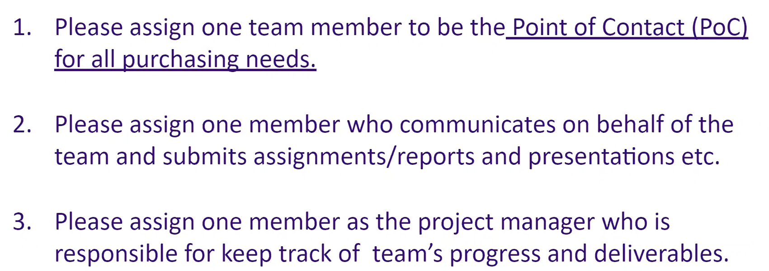

Expected contribution 15-16 hrs/week each student